Experiment 1

Searching book using Author name

STEP 1: Create Cloud Database (Supabase)
1. Open supabase.com
2. Sign up → New Project
3. Set password → Create project
4. Open SQL Editor
5. Run this SQL

CREATE TABLE public.books (
id SERIAL PRIMARY KEY,
title VARCHAR(100),
author VARCHAR(100),
price NUMERIC
);

INSERT INTO public.books (title, author, price) VALUES
('Java Basics','James',450),
('Servlet JSP','Sun',550),
('Python','Guido',400);
SELECT * FROM public.books;

1. Go to github.com
2. Create new repository
3. Click Code → Codespaces → Create

Terminal

sudo apt update

sudo apt install openjdk-17-jdk -y

wget https://archive.apache.org/dist/tomcat/tomcat-10/v10.1.18/bin/apache-tomcat-10.1.18.tar.gz

tar -xvf apache-tomcat-10.1.18.tar.gz

cd apache-tomcat-10.1.20
cd bin
./startup.sh

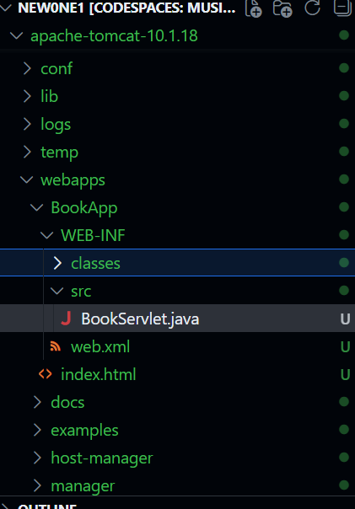

Above is the folder structure

BookServlet.java

import java.io.IOException;
import java.io.PrintWriter;
import java.sql.Connection;
import java.sql.DriverManager;
import java.sql.PreparedStatement;
import java.sql.ResultSet;

import jakarta.servlet.http.HttpServlet;
import jakarta.servlet.http.HttpServletRequest;
import jakarta.servlet.http.HttpServletResponse;

public class BookServlet extends HttpServlet {

// Handles GET request
@Override
protected void doGet(HttpServletRequest req, HttpServletResponse res)
throws IOException {

// Set response type
res.setContentType("text/html");
PrintWriter out = res.getWriter();

// Get search keyword from HTML form
String key = req.getParameter("key");

try {
Class.forName("org.postgresql.Driver");

Connection con = DriverManager.getConnection(
"jdbc:postgresql://aws-1-ap-northeast-1.pooler.supabase.com:5432/postgres?sslmode=require&connectTimeout=10",
"postgres.cehurynoqzcbuogxcayv",
"Carpediem123&456"
);

String sql = "SELECT * FROM public.books WHERE title ILIKE ? OR author ILIKE ?";

PreparedStatement ps = con.prepareStatement(sql);
ps.setString(1, "%" + key + "%");
ps.setString(2, "%" + key + "%");

// Execute query
ResultSet rs = ps.executeQuery();

// Display result in HTML table
out.println("<h2>Book List</h2>");
out.println("<table border='1'>");
out.println("<tr><th>Title</th><th>Author</th><th>Price</th></tr>");

while (rs.next()) {
out.println("<tr>");
out.println("<td>" + rs.getString("title") + "</td>");
out.println("<td>" + rs.getString("author") + "</td>");
out.println("<td>" + rs.getInt("price") + "</td>");
out.println("</tr>");
}

out.println("</table>");

// Close connection
con.close();

} catch (Exception e) {
out.println("<p>Error: " + e + "</p>");
}
}
}

Web.xml
<?xml version="1.0" encoding="UTF-8"?>

<web-app
xmlns="https://jakarta.ee/xml/ns/jakartaee"
xmlns:xsi="http://www.w3.org/2001/XMLSchema-instance"
xsi:schemaLocation="https://jakarta.ee/xml/ns/jakartaee
https://jakarta.ee/xml/ns/jakartaee/web-app_5_0.xsd"
version="5.0">

<servlet>
<servlet-name>BookServlet</servlet-name>
<servlet-class>BookServlet</servlet-class>
</servlet>

<servlet-mapping>
<servlet-name>BookServlet</servlet-name>
<url-pattern>/books</url-pattern>
</servlet-mapping>

</web-app>
Index.html

<form action="books" method="get">
Search: <input type="text" name="key">
<input type="submit" value="Search">
</form>

Database setting and then copy database addresss and put in .java file

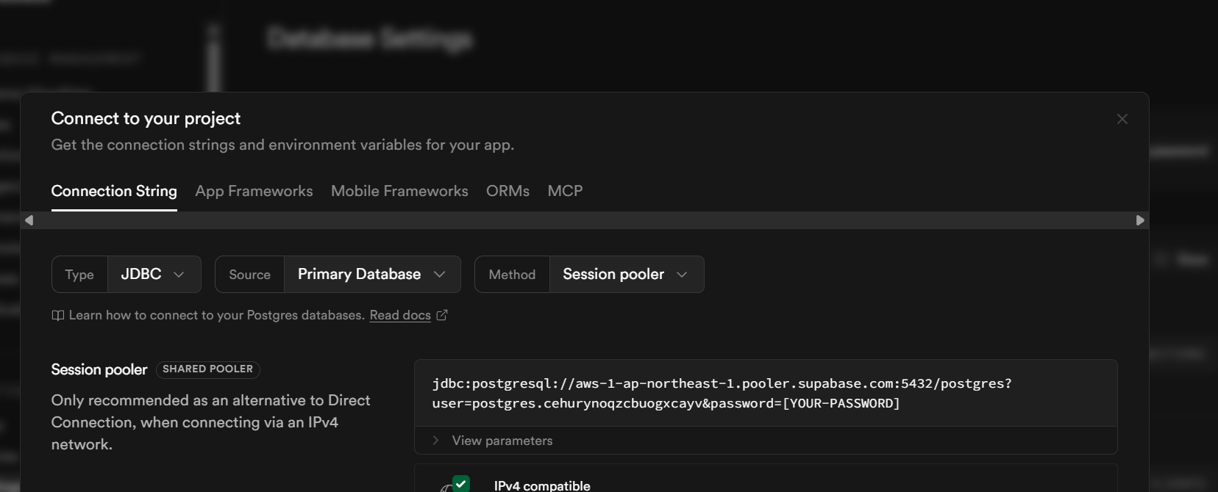

Compile java file

WEB-INF/src:
javac -cp ../../../../lib/servlet-api.jar:. BookServlet.java -d ../classes

ls classes---check
cd bin
./shutdown.sh
./startup.sh

Finally your url should be https://<codespace-id>-8080.app.github.dev/BookApp/index.html

Extras

ADD POSTGRESQL JDBC DRIVER

wget https://jdbc.postgresql.org/download/postgresql-42.7.3.jar

ls | grep postgresql

see----postgresql-42.7.3.jar

/workspaces/newone/apache-tomcat-10.1.18
mkdir -p webapps/BookApp/WEB-INF/lib
cp postgresql-42.7.3.jar webapps/BookApp/WEB-INF/lib/

WEB-INF/src:
javac -cp ../../../../lib/servlet-api.jar:. BookServlet.java -d ../classes

